**Activities to be performed in the AJP Lab**

1. Open Eclipse instance – go to File New – choose Java Project.
2. Title the project
3. Start creating the java files in the src folder by right clicking in the src folder
4. Give a class name
5. After creating the class, open the Eclipse Editor (double-click on the file just created) and start typing the program.
6. Execute the program

**Explore in Eclipse**

1. Close console view and re-open
2. Close Servers view and re-open
3. Move from Java to J2EE perspective and vice-versa. Note down the changes in the view.
4. Close Project Explorer and re-open.
5. Format the source code.
6. Increase the Editor font-size.

**NOTE: Please note down the steps executed to achieve the above, in the observation book.**

**Develop and Execute the following programs in Java by using Eclipse IDE**

1. Compute Compound Interest (Accept double values)

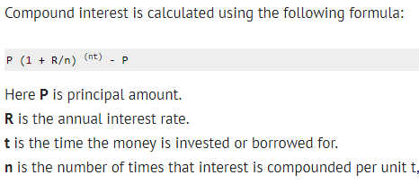

1. Find average of numbers using Array (Accept double values and print the result also in double upto three precision values after the decimal)
2. Swapping two numbers using bitwise operator (Accept the numbers from the user)
3. Reverse of a string without using string revers built-in function
4. Usage of custom Exceptions